Section A

- Complete the general formula of the alkenes.

C___H____

- Choose which of these is an alkene.
Tick ( ) one box.
- Pentane | 
- Hexene
- Heptane

- Complete the structural formula for butene:

C C C C

- The alkenes are a large family of compounds.
Determine the chemical formula of an alkene with:
- 8 carbons

_______________________________________

- 24 carbons

_______________________________________

- 36 hydrogens

_______________________________________

- 20 hydrogens

_______________________________________

- What happens when bromine water is added to an alkene?
Tick ( ) one box.
- Bromine water turns cloudy
- Bromine water turns colourless
- Bromine water stays orange

- Which explains why alkenes are described as unsaturated?
Tick ( ) one box.
- They contain a double bond between carbon atoms
- They contain a double bond between carbon and hydrogen atoms
- They contain only single bonds

Section B

- Complete the dot and cross diagram to show the bonding in ethene.

- Predict the products of the following reactions.

- Propene + hydrogen

- Pentene + hydrogen

- Hexene + hydrogen

- Propene + bromine

- Pentene + chlorine

- Hexene + iodine

- Describe what is required for an alkene to react with hydrogen.

__________________________________________________________________________________________
__________________________________________________________________________________________

- Explain how alkenes are produced from crude oil using fractional distillation and cracking.

__________________________________________________________________________________________
__________________________________________________________________________________________
__________________________________________________________________________________________
__________________________________________________________________________________________
__________________________________________________________________________________________
__________________________________________________________________________________________
__________________________________________________________________________________________
__________________________________________________________________________________________

- Cycloalkenes are alkenes that are ring-shaped and contain a double bond between carbon atoms.

The chemical formulae of three cycloalkenes are given below.

Name | Formula
Cyclobutene | C₄H₆
Cyclopentene | C₅H₈
Cyclohexene | C₆H₁₀

- Use the information to determine the general formula of cycloalkenes.

_______________________________________
The structural formula of cyclohexene is shown below.

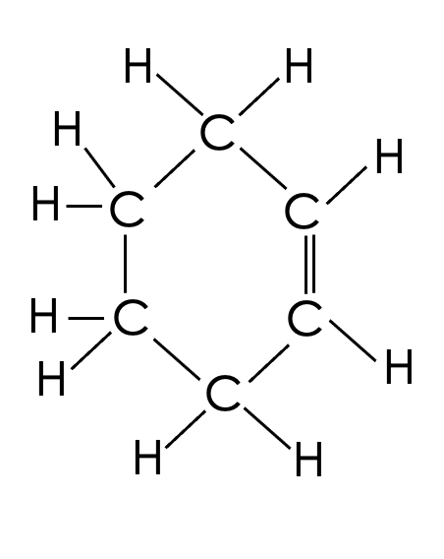

- Cyclohexene reacts with chlorine. Complete the structural formula to show the compound formed when cyclohexene reacts with chlorine.

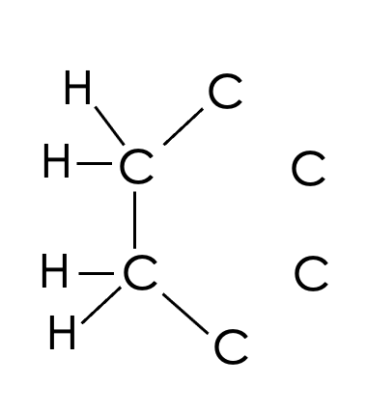

Section C

- Alkenes are a homologous series of hydrocarbons.
- Define a homologous series.
- Define a hydrocarbon.
- A scientist has a mixture of different alkenes. Describe and explain how they could separate them.
- Identify the type of bonding in alkenes.
- Explain why the alkenes have relatively low melting and boiling points.
- Hexene is an alkene that contains 6 carbon atoms. Describe what happens to the particles when hexene is heated past its boiling point.
- Hexene has a boiling point of 63 ºC. What state is it in at room temperature?
- Hexene has a specific heat capacity of 183 J/kg ºC. Calculate how much energy is required to heat 100 g of hexene from room temperature (20 ºC) to its boiling point.

